Access to Medical Services 2015
Q1. In general how easy is it for you to get an appointment for the time you wanted?
Very easy 9%
Fairly easy 38%
Not very easy 50%
Not applicable 2%
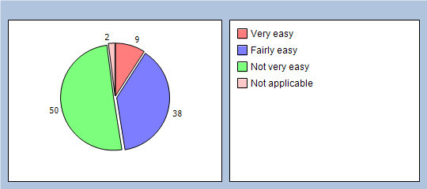
Q2. Would you like to provide any additional comments about this?

(See attached)

Q3. What times of appointments would be most convenient to you in order to aid your access to see a doctor or nurse?
Before 8am 13%
Over lunchtime 11%
After 6:00pm 36%
On a Saturday 11%
Happy as they are 40%

Q4. In general how easy is it to book an appointment with a GP or Nurse in advance i.e. more than a week away?
Very easy 20%
Fairly easy 47%
Not very easy 29%
Not applicable 2%
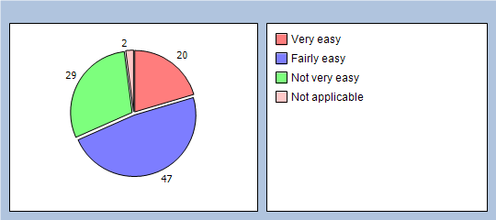

Q5. Did you see a GP or Nurse today?
GP 29%
Nurse 36%
Other 11%
Not applicable 22%
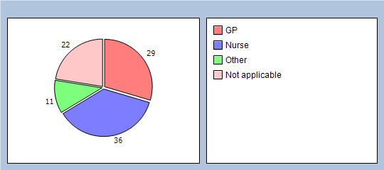

Q6. When you arrived at the surgery today how long did you have to wait after your appointment time to be seen?
0-5 minutes 20%
5-15 minutes 50%
15-30 minutes 22%
30-45 minutes 0%
45 - 60 minutes 0%
Longer than 1 hour 0%
No response 8%
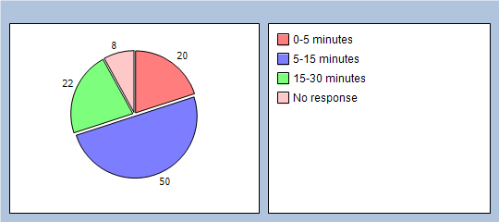

Q7. Did you have confidence in the GP or Nurse that you had your appointment with today?
Yes 90%
No 4%
Not applicable 2%
No response 4%
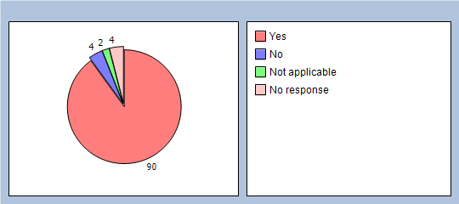
Q8. Do you have any suggestions or comments about how we might be able to improve access to our surgery for urgent medical care or help educate our patients on the options available to them?

(See attached)

Q9. How likely are you to recommend our services to friends or family if they needed similar care or treatment
Extremely likely 43%
Likely 38%
Neither likely nor unlikely 6%
Unlikely 9%
Extremely unlikely 0%
Don't know 2%
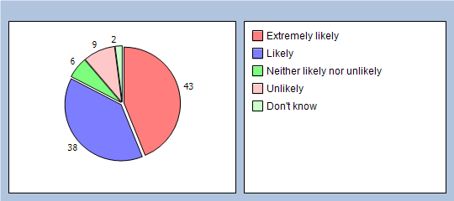

To help us analyse your answers please tell us a few things about yourself. This section is optional and does not form part of the main survey. Are you male or female?
Male 36%
Female 61%
Declined to comment 2%
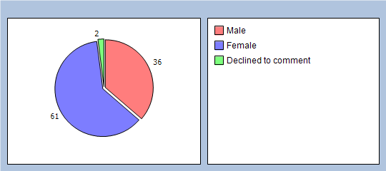

What age are you?
Under 16 6%
17-24 11%
25-34 18%
35-44 15%
45-54 20%
55-64 15%
65-74 6%
75-85 2%
Over 84 0%
Declined to comment 2%
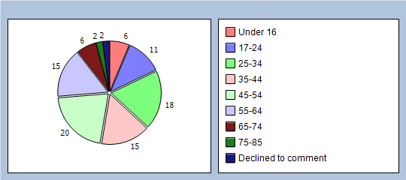

What is the ethnic background which you most identify?
White British 93%
White Irish 0%
Mixed White & Black Caribbean 0%
Mixed White & Black African 0%
Mixed White & Black Asian 0%
Indian 0%
Pakistani 0%
Bangladeshi 0%
Black Caribbean 0%
Black African 0%
Chinese 0%
Other 2%
Declined to comment 2%
No response 3%
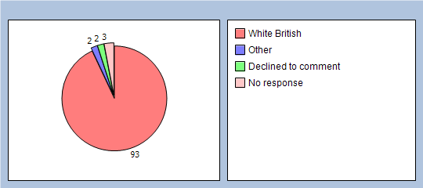

How would you describe how often you come to the practice?
Regularly 18%
Occasionally 59%
Very rarely 15%
Declined to comment 4%
No response 4%
